**TASK 1 –**

**INSTALLING TOMCAT ON DOCKERS**

**>***docker search tomcat*

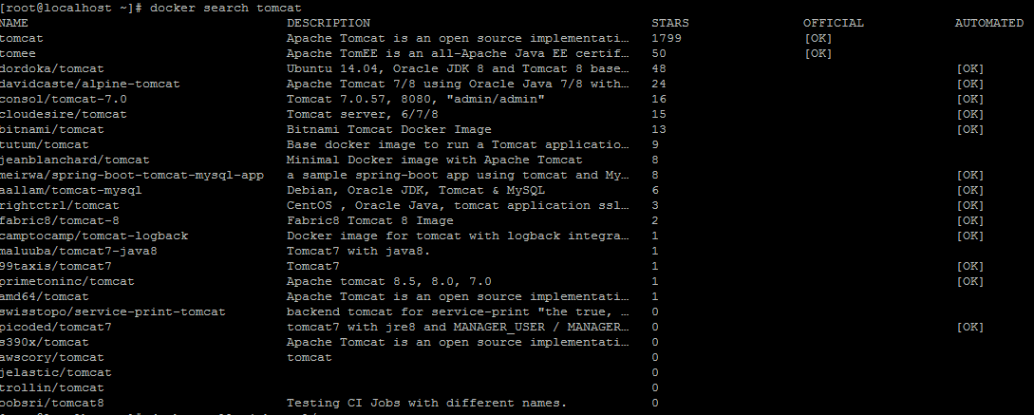

>*docker pull rightctrl/tomcat*

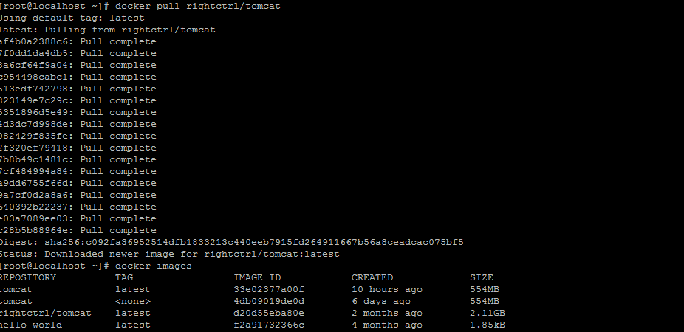

> docker run rightctrl/tomcat

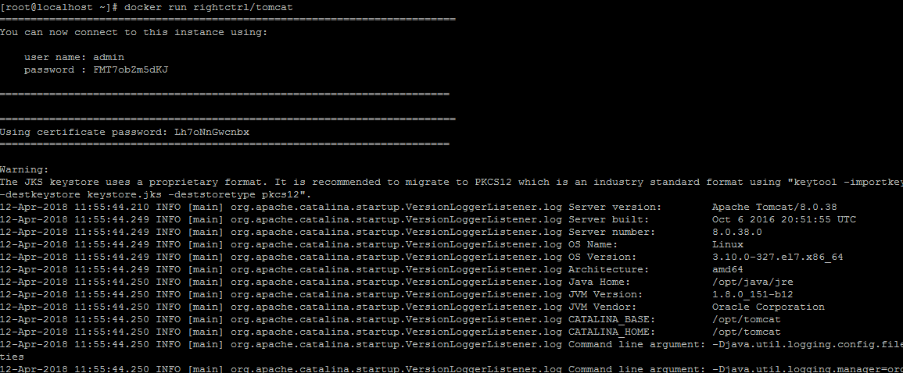

It will start running now.

Pressing ctrl+c now will stop it.So open a new session to continue working.

>docker ps

>docker inspect -f format='{{.NetworkSettings.IPAddress}}' <container id>

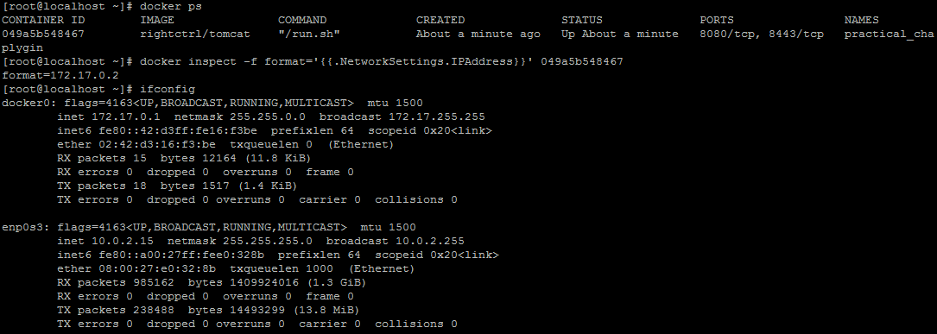

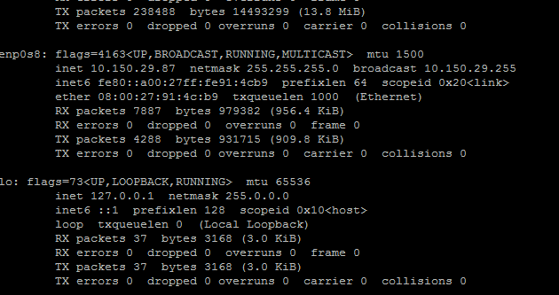

Now, we need to enable port forwarding so that we can run the tomcat on the vm machine as well as our host machine too.

We need to run the tomcat with another command.

So we ll be killing the current tomcat running and start it again.

>

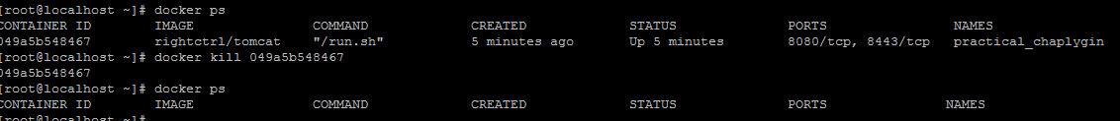

Enabling port forwarding on vm machine-

* Go to settings->network->nat adapter -> port forwarding -> then image

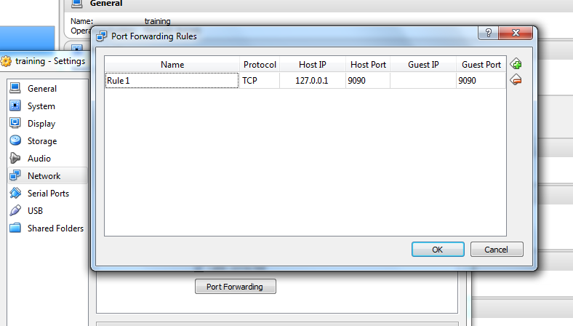

Now.run it again with the below command-

* docker run -ti --rm --name server -p 9090:8080 rightctrl/tomcat

This will forward port 8080 to 9090.

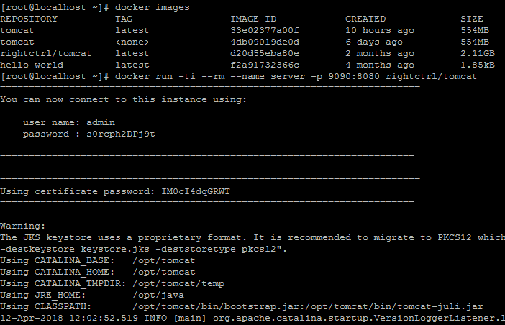

Now in the another session-

>docker ps

>docker inspect <container id>

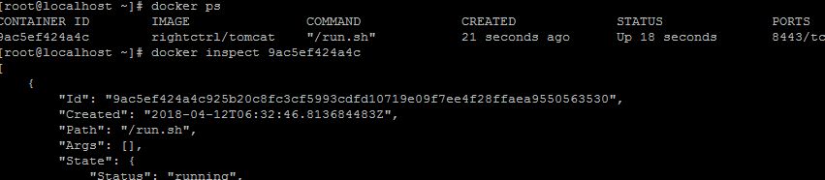

Now check the ip address at the bottom of the inspect command.

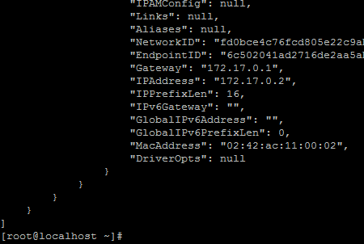

This returns the ip address of 172.17.0.2 so we can open this ip address and port 8080 to see the Tomcat installation.

On VM – tomcat will be running on

* <docker ip-i.e 172.17.0.2 here>: 8080
* localhost:9090

On Host machine –it will run on

<http://localhost:9090/>

**TASK-2**

Configure the Jenkins to do the deployments in docker container

* Create a new freestyle project. Configure it like below

Provide the repository url from where you want to take your code from. It must be containing a war file. And provide the corresponding credentials of that repo only.

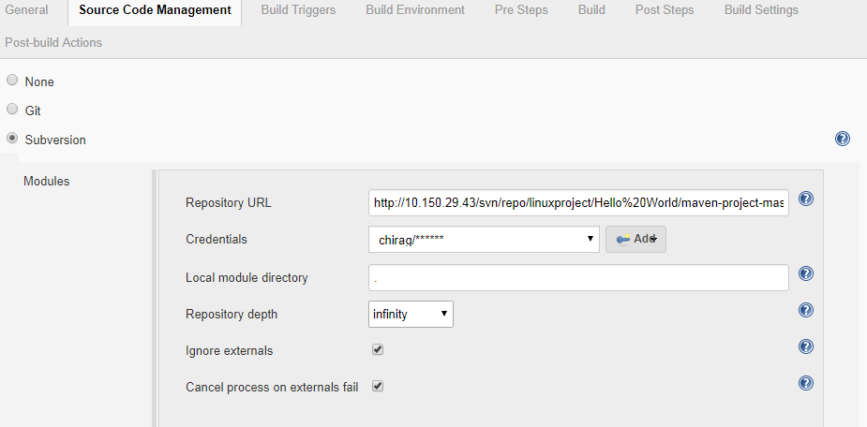

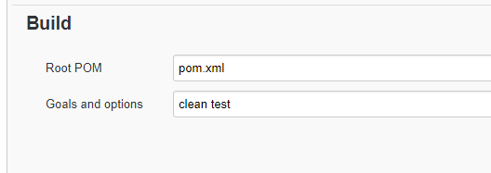

* In post build actions-

In tomcat credentials- put the credentials of tomcat which is running in docker container.

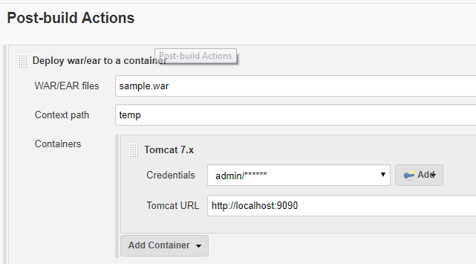

You can check the tomcat credentials (if don’t know already) by following the below commands-

* docker ps
* docker run -i -t fabric8/tomcat-8 /bin/bash (to enter in the running container)
* cd /opt/tomcat/conf
* vim tomcat-users.xml

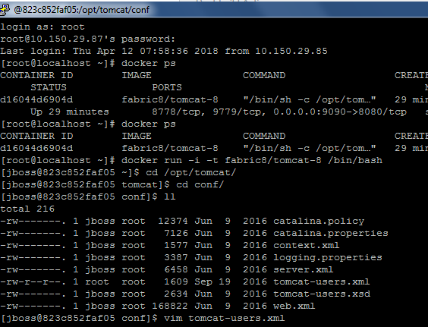

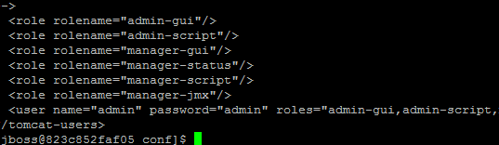

* Now we can check the deployment on <http://localhost:9090/manager/html> for our host machine and on <http://172.17.0.2:8080/manager/html> on vm.

Follow this link for port forwarding details- <https://stackoverflow.com/questions/27471688/how-to-access-tomcat-running-in-docker-container-from-browser>